**AMERICAN INTERNATIONAL UNIVERSITY–BANGLADESH (AIUB)**

**Dept. of Computer Science**

**Faculty of Science and Technology**

**CSC 2108: Introduction To Database**

**Spring 2022-2023**

**Section: H**

**Group:10**

**Project On**

**Metro Rail Management System**

**Supervised By**

**KAWSER IROM RUSHEE**

**Submitted By:**

|  |  |
| --- | --- |
| **Name** | **ID** |
| **1. Abdullah Adnan Abul Kalam** | **22-47846-2** |
| **2. Md Sakib Hasan** | **22-47142-1** |
| **3. Md Arifur Rahman** | **22-47110-1** |
| **4. Abdullah Al Taieb** | **22-48028-2** |

**Content List:**

1. Case Scenario
2. ER Diagram
3. Normalization
4. Table Creation
5. Data Insertion
6. Query Writing
7. Conclusion

**Case Scenario:**

The main entities of this metro rail management system are MetroTrain, Station, Employee,Passenger and Ticket. Each station has unique Id and also they have naame. Metro Train passes station and each train has name,number, capacity, Route, and Compartment.While passing the station duration is stored. Many train passes many station. Station serves many passenger. Each passenger has name , unique Id , Contact number , Destination and Boarding place. One Passenger can have multiple contact number. Station has employees. Each Employee has unique Id . They have Name , Age , Date of Birth, their working type and ContactNumber . One employee can have multiple contact number. Employee also has also specific Address. Inside that Adress there is street number , street name , city and country. Every passenger buys ticket.And one ticket can be bought by only one passenger . One passenger can buy multiple ticket. Each Ticket has their unique Id. There is also the price of the ticket and the date when the ticket was purchased.

**ER-Diagram:**

Screenshot of ER diagram just after beginning-

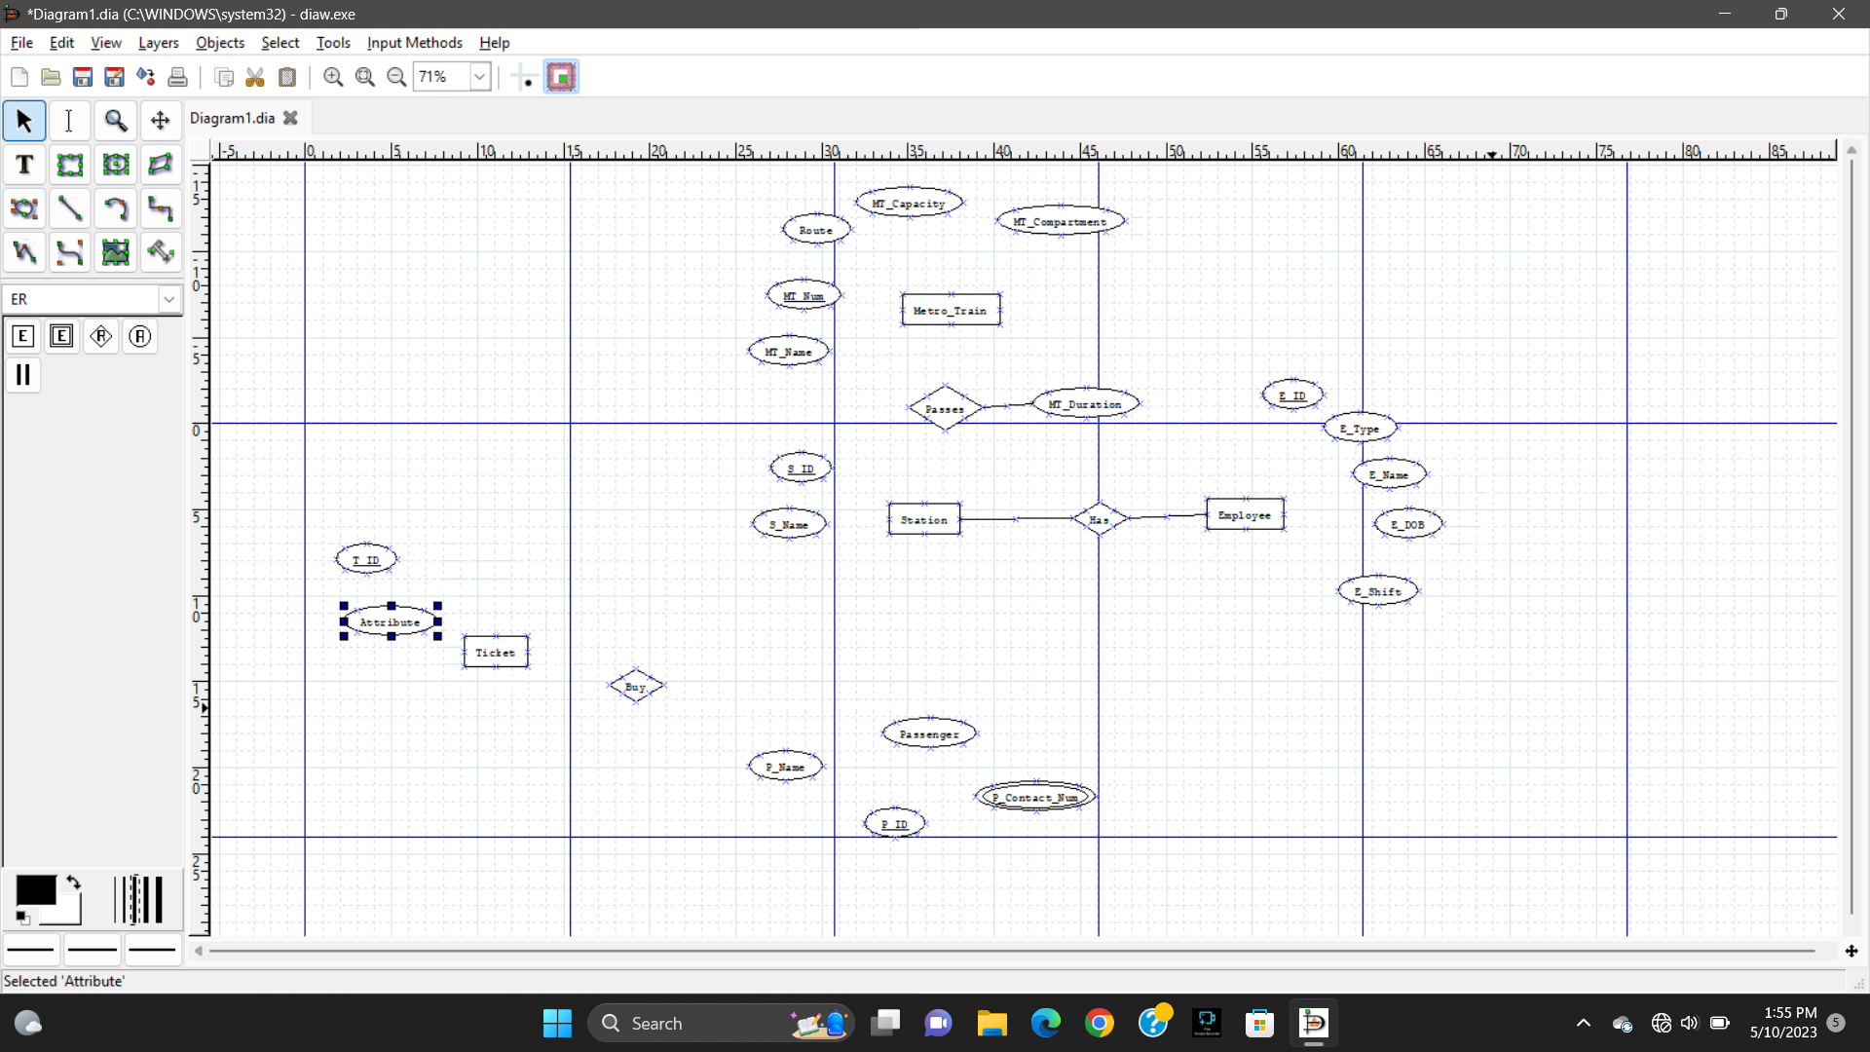

Screenshot of ER diagram in the middle:

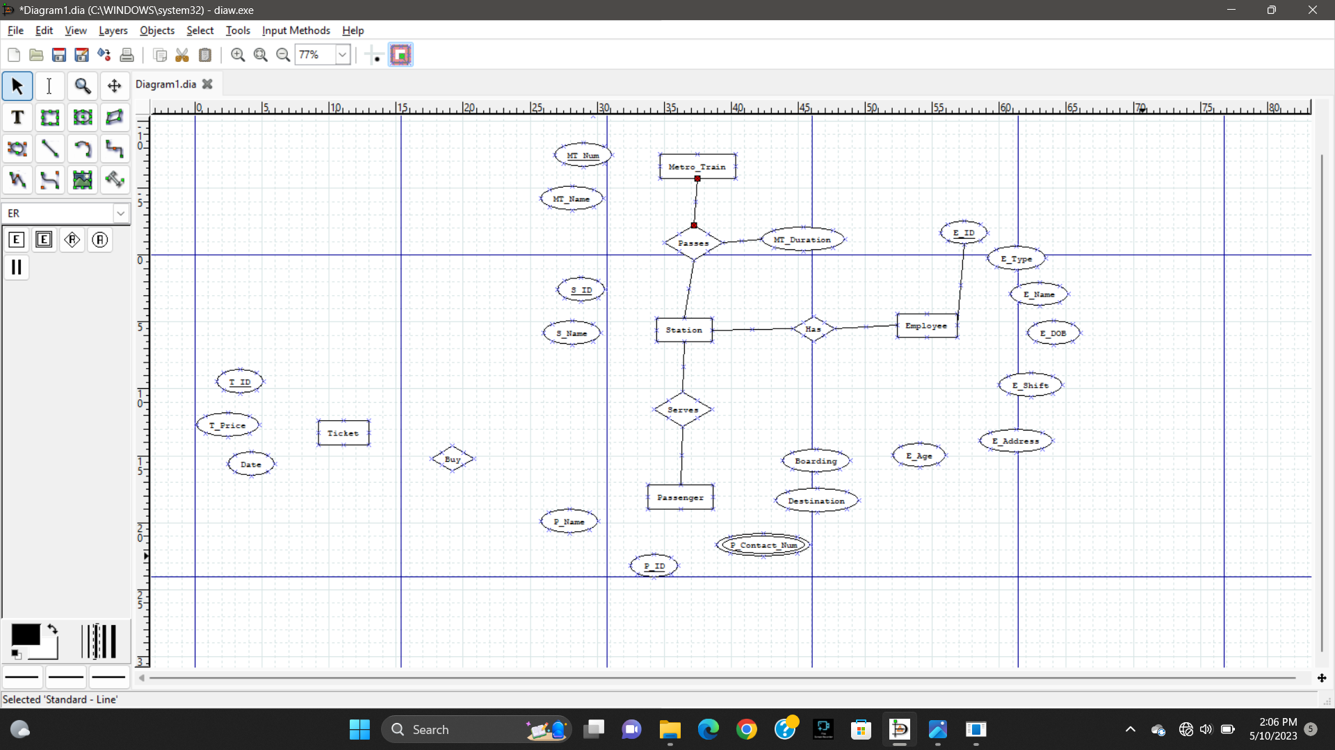

Final ER diagram:

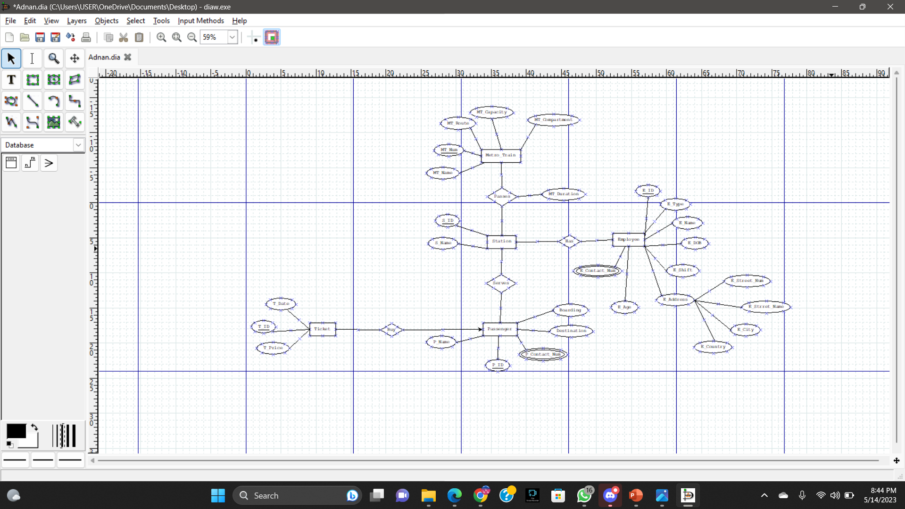

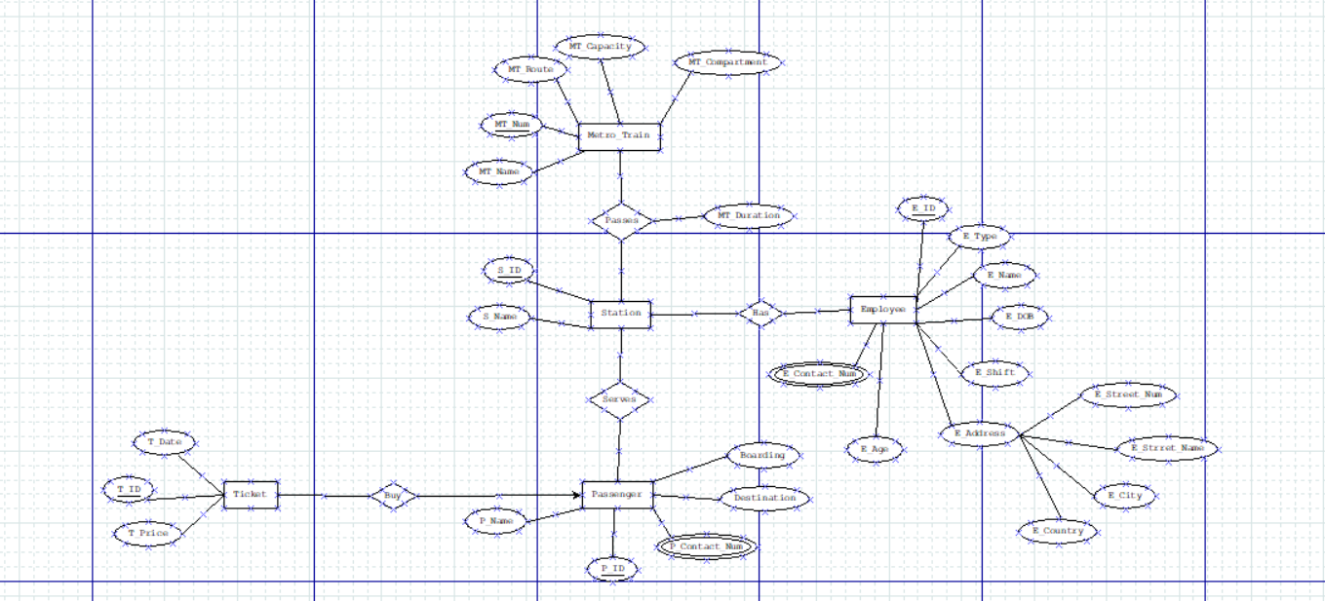

Figure: ER-Diagram

Normalization:

**Passes**

**Metro Train Passes Station:**

**UNF**

Passes (MT_Name, MT_Num, MT_Route, MT_Capacity,MT_Compartment,MT_Duration, S_ID, S_Name)

**1NF:**

There is no multi valued attribute, It is already 1NF.

1. MT_Name, MT_Num, MT_Route, MT_Capacity,MT_Compartment, MT_Duration, S_ID, S_Name

**2NF:**

1. MT_Name, MT_Num, MT_Route, MT_Capacity,MT_Compartment, MT_Duration,

2. S_ID, S_Name

**3NF:**

There is no transitive relationship, It is already 3NF.

1. MT_Name, MT_Num, MT_Route, MT_Capacity,MT_Compartment, MT_Duration,

2. S_ID, S_Name

**TABLE CREATION:**

1. MT_Name, MT_Num, MT_Route, MT_Capacity,MT_Compartment, MT_Duration,

2. S_ID, S_Name

3. **MT_Num**, **S_ID**

**Serves**

**Station Serves Passenger:**

**UNF:**

S_ID, S_Name, P_ID, P_Name,P_Contact_Num,Destination,Boarding

**1NF:**

P­_Contact_Num is multivalued attribute

1. S_ID, S_Name, P_ID, P_Name, P_Contact_Num, Destination, Boarding

**2NF:**

1. S_ID, S_Name

2. P_ID, P_Name, P_Contact_Num, Destination, Boarding

**3NF:**

There is no transitive relationship, It is already 3NF.

1. S_ID, S_Name

2. P_ID, P_Name, P_Contact_Num, Destination, Boarding

**TABLE CREATION:**

1. S_ID, S_Name

2. P_ID, P_Name, P_Contact_Num, Destination, Boarding

3. **S_ID**, **P_ID**

**Has**

**Station Has Employee:**

**UNF:**

Has (S_ID, S_Name, E_ID, E_Type, E_Name, E_DOB, E_Shift, E_Street_Num, E_Street_Name, E_City, E_Country, E_Age, E_Contact_Num)

**1NF:**

E_Contact_Num is multivalued attribute.

1. S_ID, S_Name, E_ID, E_Type, E_Name, E_DOB, E_Shift, E_Street_Num, E_Street_Name, E_City, E_Country, E_Age, E_Contact_Num

**2NF:**

1. S_ID, S_Name

2. E_ID, E_Type, E_Name, E_DOB, E_Shift, E_Street_Num, E_Street_Name, E_City, E_Country, E_Age, E_Contact_Num

**3NF:**

1. S_ID, S_Name

2. E_ID, E_Type, E_Name, E_DOB, E_Shift, E_Age, E_Contact_Num

3. E_Street_Num, E_Street_Name, E_City, E_Country

**TABLE CREATION:**

1. S_ID, S_Name

2. E_ID, E_Type, E_Name, E_DOB, E_Shift, E_Age, E_Contact_Num, E_Address_ID

3. E_Address_ID, E_Street_Num, E_Street_Name, E_City, E_Country

4. **S_ID**, **E_ID**

**BUY**

**Passenger Buy Ticket:**

**UNF:**

BUY (P_ID, P_Name, P_Contact_Num, Destination, Boarding, T_ID, T_Price, T_Date)

**1NF:**

P_Contact_Num is multivalued attribute.

1. P_ID, P_Name, P_Contact_Num, Destination, Boarding, T_ID, T_Price, T_Date

**2NF:**

1. P_ID, P_Name, P_Contact_Num, Destination, Boarding

2. T_ID, T_Price, T_Date

**3NF:**

There is no transitive relationship, It is already 3NF.

1. P_ID, P_Name, P_Contact_Num, Destination, Boarding

2. T_ID, T_Price, T_Date

**TABLE CREATION:**

1. P_ID, P_Name, P_Contact_Num, Destination, Boarding

2. T_ID, T_Price, T_Date, P_ID

**Temporary Table:**

1. MT_Name, MT_Num, MT_Route, MT_Capacity,MT_Compartment, MT_Duration,

2. S_ID, S_Name

3. **MT_Num**, **S_ID**

~~3. S_ID, S_Name~~

4. P_ID, P_Name, P_Contact_Num, Destination, Boarding

**5. S_ID**, **P_ID**

~~5. S_ID, S_Name~~

6. E_ID, E_Type, E_Name, E_DOB, E_Shift, E_Contact_Num, **E_Address_ID**

7. E_Address_ID, E_Street_Num, E_Street_Name, E_City, E_Country

4. **S_ID**, **E_ID**

~~8. P_ID, P_Name, P_Contact_Num, Destination, Boarding~~

9. 2. T_ID, T_Price, T_Date, **P_ID**

**Final Table:**

1. MT_Num , MT_Name, MT_Route, MT_Capacity,MT_Compartment, MT_Duration

2. S_ID, S_Name

3. **MT_NUM**, **S_ID**

4. P_ID, P_Name, P_Contact_Num1, P_Contact_Num2, Destination, Boarding

**5. S_ID**, **P_ID**

6. E_ID, E_Type, E_Name, E_DOB, E_Shift, E_Contact_Num1, E_Contact_Num2, **E_Address_ID**

7. E_Address_ID, E_Street_Num, E_Street_Name, E_City, E_Country

8. **S_ID**, **E_ID**

9. T_ID, T_Price, T_Date, P_ID

**TABLE CREATION QUERY:**

**Table-01: Metro_Info**

CREATE TABLE Metro_Info

( MT_Num int Primary Key,

MT_Name VARCHAR2(20) NOT NULL,

MT_Route VARCHAR2(50) NOT NULL,

MT_Capacity NUMBER(4) NOT NULL,

MT_Compartment VARCHAR2(100) NOT NULL,

MT_Duration VARCHAR2(10) NOT NULL

);

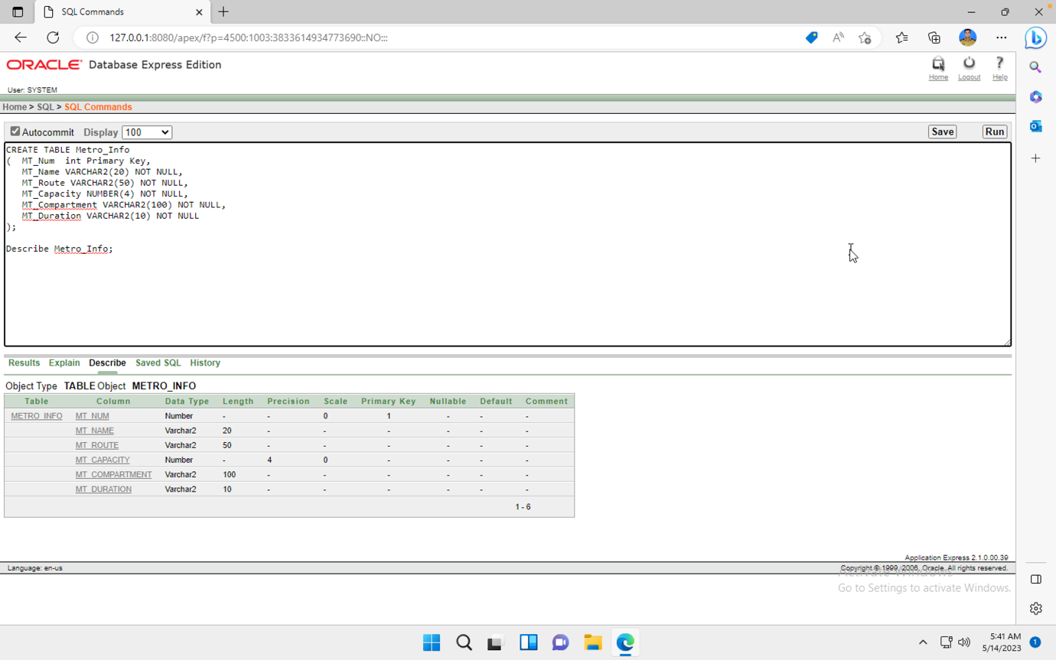

**Table-02: Station_Info**

CREATE TABLE Station_Info

( S_ID int Primary Key,

S_Name VARCHAR(40) NOT NULL);

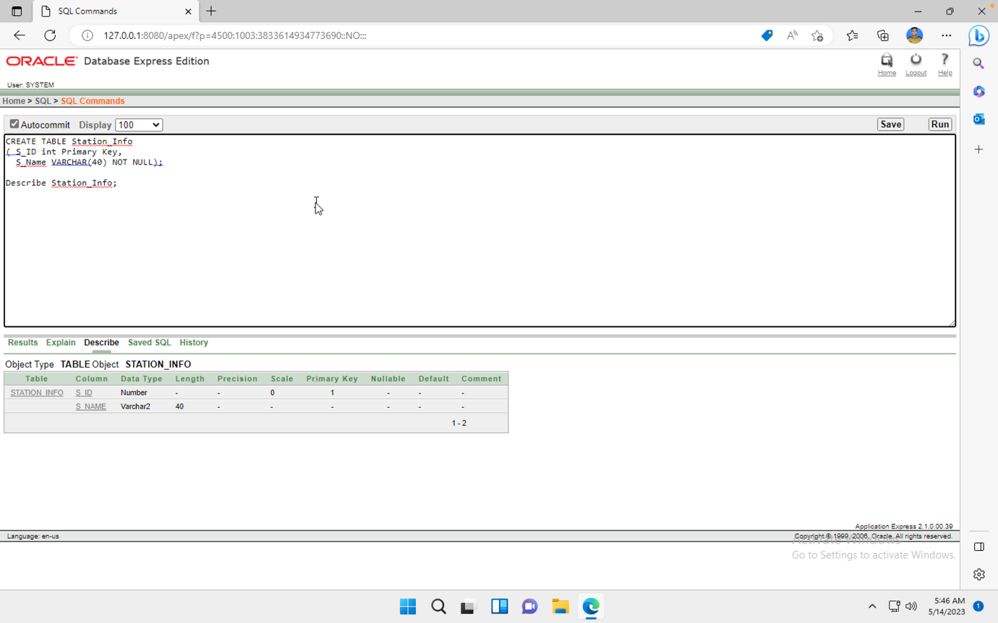

**Table-03: Metro_Station**

CREATE TABLE Metro_Station

( MT_Num int ,

S_ID int ,

primary key(MT_Num, S_ID),

Foreign Key (MT_Num) references Metro_Info(MT_Num),

Foreign Key (S_ID) references Station_Info(S_ID));

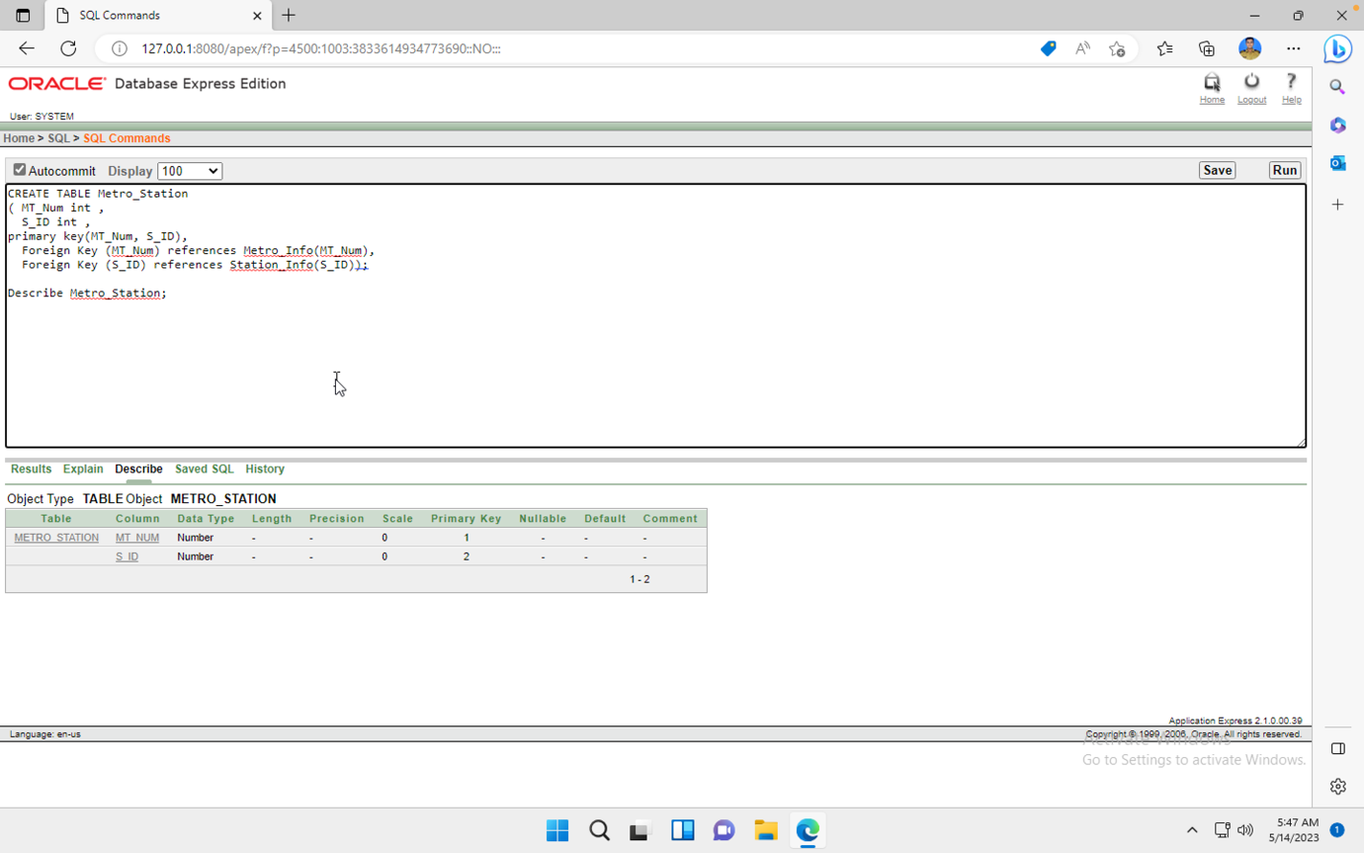

**Table-04: Passenger_Info**

CREATE TABLE Passenger_Info

( P_ID int Primary Key,

P_Name VARCHAR2(50) NOT NULL,

P_Contact_Num1 NUMBER(11) NOT NULL,

P_Contact_Num2 NUMBER(11),

Destination VARCHAR2(50) NOT NULL,

Boarding VARCHAR2(50) NOT NULL

);

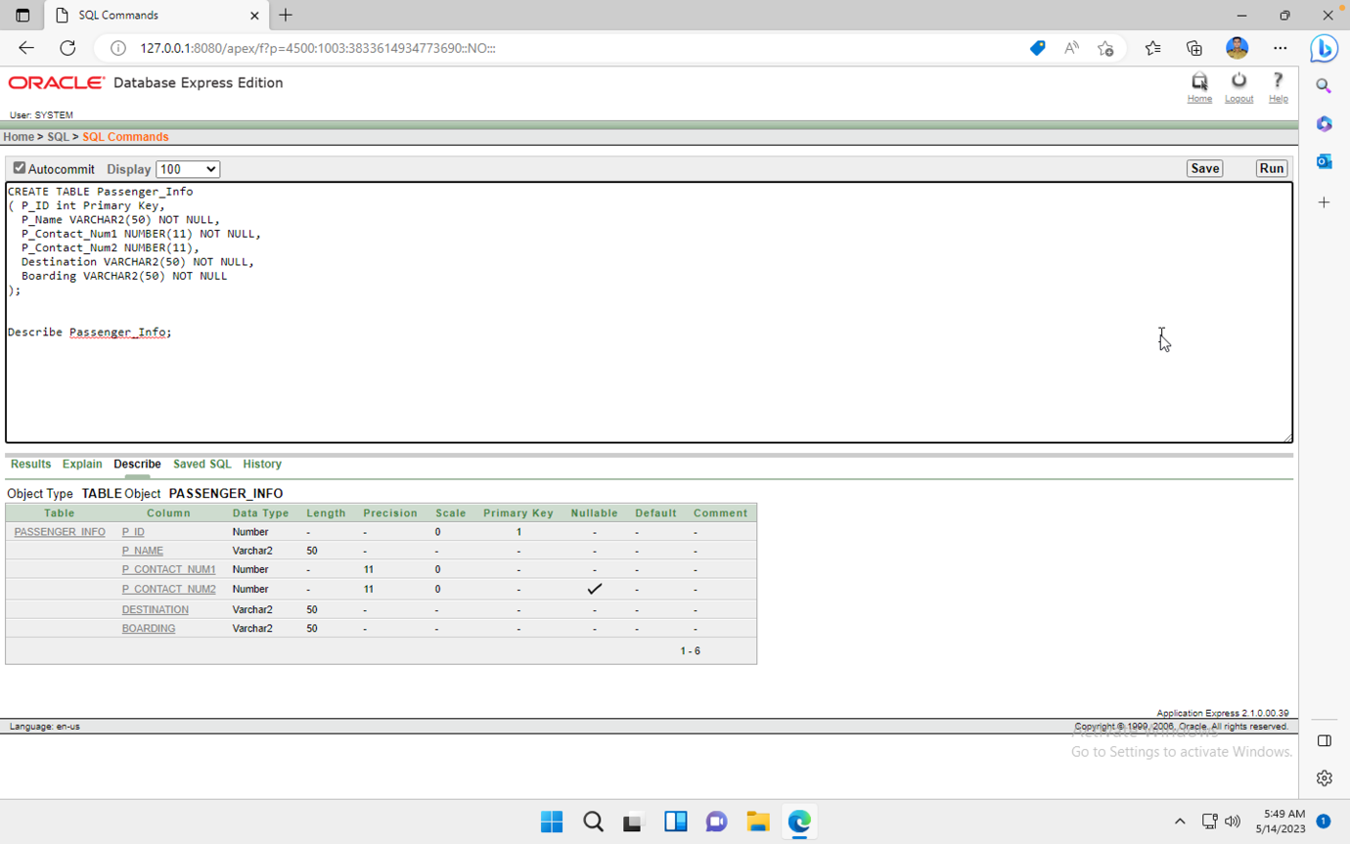

**Table-05: Station_Passenger**

CREATE TABLE Station_Passenger

( S_ID int,

P_ID int,

Primary Key(S_ID,P_ID),

Foreign Key (S_ID) references Station_Info(S_ID),

Foreign Key (P_ID) references Passenger_Info(P_ID)

);

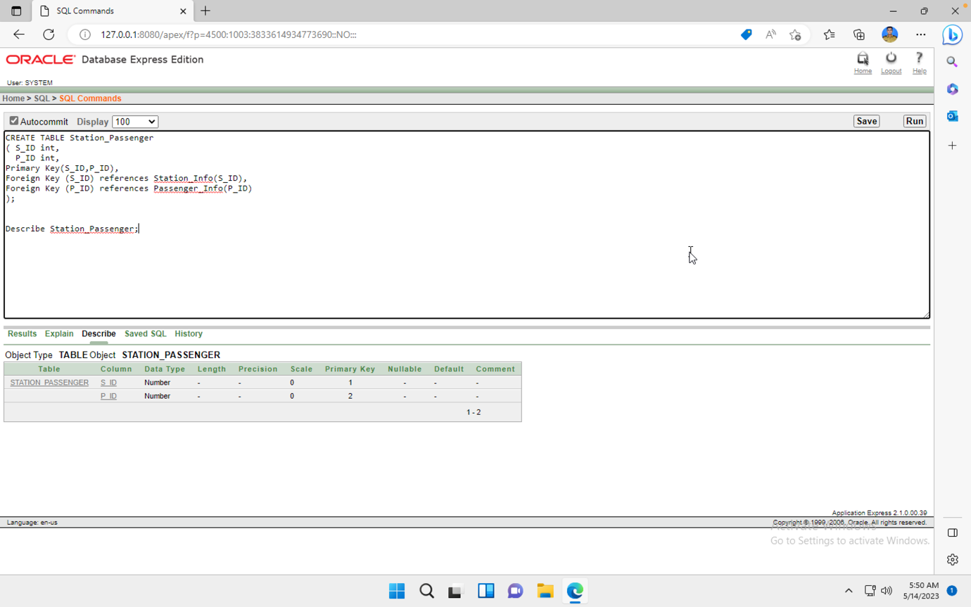

**Table-06: Employee_Address**

CREATE TABLE Employee_Address

(

E_Address_ID INT PRIMARY KEY,

E_Street_Num VARCHAR2(50),

E_City VARCHAR2(20),

E_Country VARCHAR2(20)

);

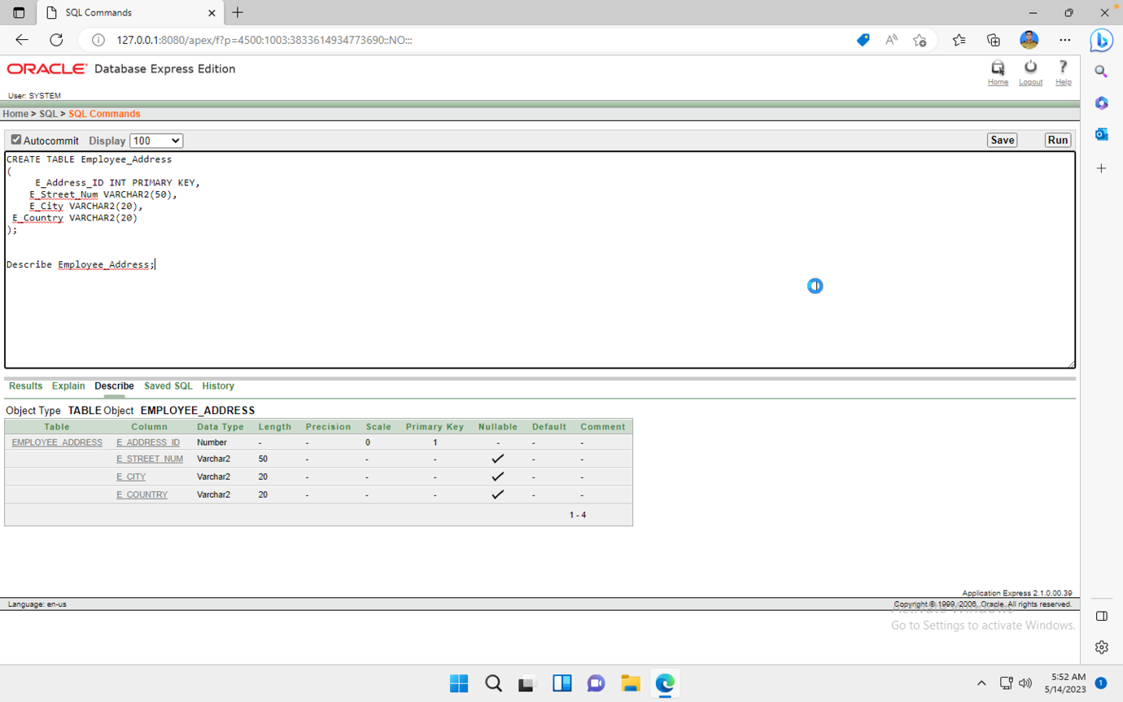

**Table-07: Employee_Info**

CREATE TABLE Employee_Info

(

E_ID INT PRIMARY KEY,

E_Type VARCHAR2(15) CHECK(E_Type IN('Station Manager', 'Ticketing Staff', 'Security Personnel', 'Train Operators', 'Maintenance Staff', 'Cleaning Staff')) NOT NULL,

E_Name VARCHAR2(50) NOT NULL,

E_DOB DATE,

E_Shift VARCHAR2 (15) CHECK (E_Shift IN('DAY','NIGHT')) NOT NULL,

E_Contact_Num1 Number(11) NOT NULL,

E_Contact_Num2 Number(11),

E_Address_ID INT NOT NULL,

FOREIGN KEY(E_Address_ID) REFERENCES Employee_Address(E_Address_ID));

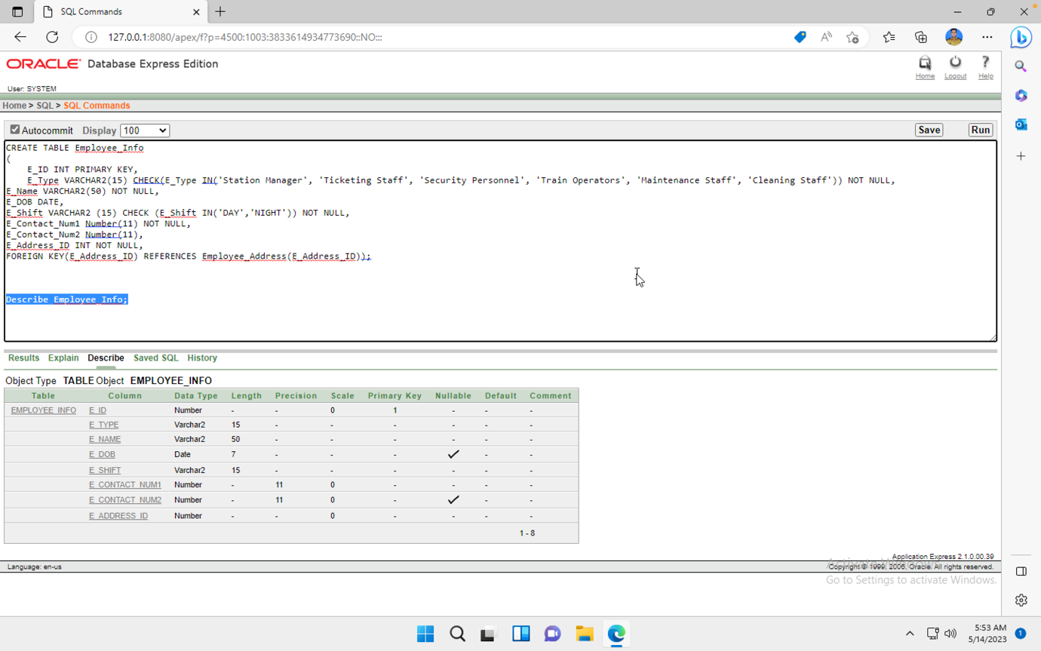

**Table-08: Station_Employee**

CREATE TABLE Station_Employee

( S_ID int NOT NULL,

E_ID int NOT NULL,

Primary Key (S_ID, E_ID),

FOREIGN KEY(S_ID) REFERENCES Station_Info(S_ID),

FOREIGN KEY(E_ID) REFERENCES Employee_Info(E_ID));

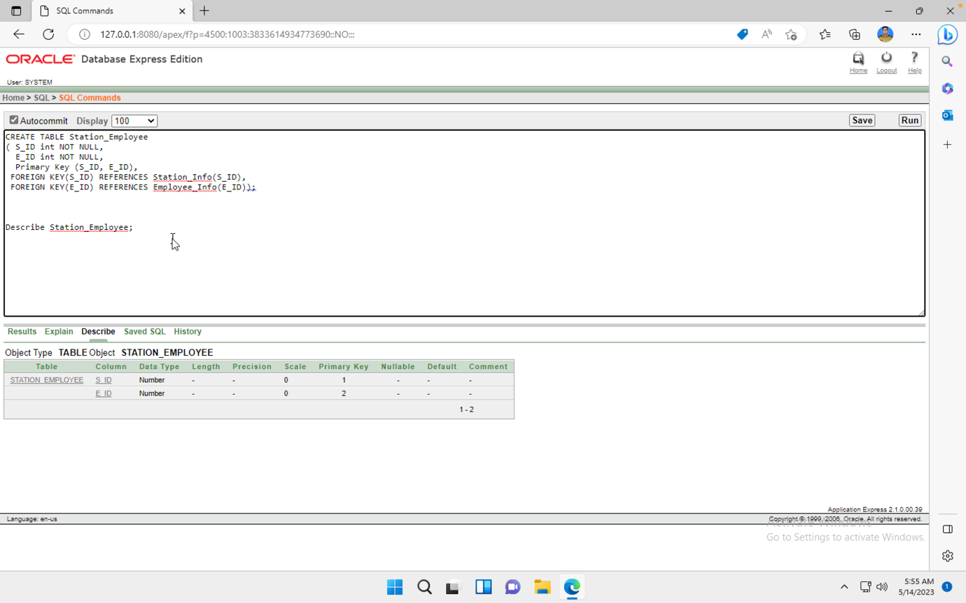

**Table-09: Ticket**

CREATE TABLE Ticket

( T_ID int Primary Key,

T_Price NUMBER(10) NOT NULL,

P_ID int NOT NULL,

FOREIGN KEY(P_ID) REFERENCES Passenger_Info(P_ID));

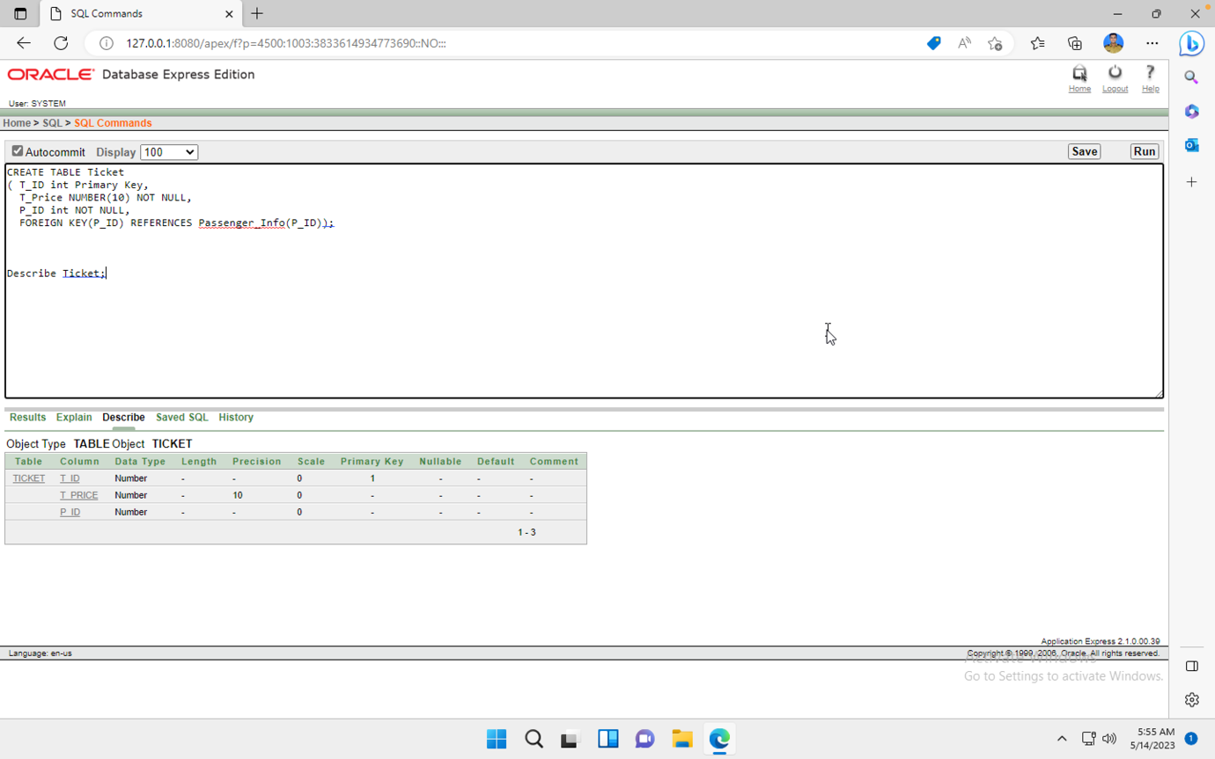

**Data Insertion:**

**Table-01: Metro_Info**

Insert into Metro_Info Values

(MT_Num_seq.NEXTVAL,'Bangabandhu Express', 'Uttara North',500,'20','5 Mins');

Insert into Metro_Info Values

(MT_Num_seq.NEXTVAL,'Sonar Bangla Express', 'Pallabi',400,'15','5 Mins');Insert into Metro_Info Values

(MT_Num_seq.NEXTVAL,'Joy Bangla Express', 'Pallabi',400,'15','5 Mins');

Insert into Metro_Info Values

(MT_Num_seq.NEXTVAL,'Mahanagar Godhuli', 'Mirpur 11',600,'30','10 Mins');

Insert into Metro_Info Values

(MT_Num_seq.NEXTVAL,'Udayan Express', 'Farmgate',550,'40','7 Mins');

select *

from Metro_Info;

**Table-02: Station_Info**

Insert into Station_Info Values

(S_ID_seq.NEXTVAL,'Pallabi');

Insert into Station_Info Values

(S_ID_seq.NEXTVAL,'Mirpur 1');

Insert into Station_Info Values

(S_ID_seq.NEXTVAL,'Uttara North');

Insert into Station_Info Values

(S_ID_seq.NEXTVAL,'Uttara South');

Insert into Station_Info Values

(S_ID_seq.NEXTVAL,'Farm gate');

select *

from Station_Info;

**Table-03: Metro_Station**

Insert into Metro_Station values

(MT_Num_fk1.NEXTVAL, S_ID_fk1.NEXTVAL);

Insert into Metro_Station values

(MT_Num_fk1.NEXTVAL, S_ID_fk1.NEXTVAL);

Insert into Metro_Station values

(MT_Num_fk1.NEXTVAL, S_ID_fk1.NEXTVAL);

Insert into Metro_Station values

(MT_Num_fk1.NEXTVAL, S_ID_fk1.NEXTVAL);

Insert into Metro_Station values

(MT_Num_fk1.NEXTVAL, S_ID_fk1.NEXTVAL);

select *

from Metro_Station;

**Table-04: Passenger_Info**

Insert into Passenger_Info values

( P_ID_seq.NEXTVAL, 'Abdullah Adnan',1924029299,1779169291,'Uttara North','Uttara South');

Insert into Passenger_Info values

( P_ID_seq.NEXTVAL, 'Basharul Alam',1813890622,NULL,'Pallabi','Farm gate');

Insert into Passenger_Info values

( P_ID_seq.NEXTVAL, 'Fatema Akhter',1344029435,1659160421,'Agargaon','Uttara North');

Insert into Passenger_Info values

( P_ID_seq.NEXTVAL, 'Nowshin Ahmed',1876244229,1432362341,'Badda','Farm gate');

Insert into Passenger_Info values

( P_ID_seq.NEXTVAL, 'Sakib Hasan',1652342366,1780134651,'Mirpur 11','Uttara South');

select *

from Passenger_Info;

**Table-05: Station_Passenger**

Insert into Station_Passenger values

( S_ID_fk2.NEXTVAL,P_ID_fk1.NEXTVAL);

Insert into Station_Passenger values

( S_ID_fk2.NEXTVAL,P_ID_fk1.NEXTVAL);

Insert into Station_Passenger values

( S_ID_fk2.NEXTVAL,P_ID_fk1.NEXTVAL);

Insert into Station_Passenger values

( S_ID_fk2.NEXTVAL,P_ID_fk1.NEXTVAL);

Insert into Station_Passenger values

( S_ID_fk2.NEXTVAL,P_ID_fk1.NEXTVAL);

select *

from Station_Passenger;

**Table-06: Employee_Address**

Insert into Employee_Address value

( E_Address_ID_seq.NEXTVAL,'Road:06 E Block','Bashundhara, Dhaka','Bangladesh');

Insert into Employee_Address value

( E_Address_ID_seq.NEXTVAL,'Road:07 Taltola','Khilgaon, Dhaka','Bangladesh');

Insert into Employee_Address value

( E_Address_ID_seq.NEXTVAL,'Road:13/2, Kawla','Airport, Dhaka','Bangladesh');

Insert into Employee_Address value

( E_Address_ID_seq.NEXTVAL,'Road: B-6 Mugda',' Dhaka','Bangladesh');

Insert into Employee_Address value

( E_Address_ID_seq.NEXTVAL,'Road:08 C Block','Bashundhara, Dhaka','Bangladesh');

select *

from Employee_Address;

**Table-07: Employee_Info**

Insert into Employee_Info values

( E_ID_seq.NEXTVAL,'Station Manager', 'Jubayer Ahmed',TO_DATE('1985-06-11', 'yyyy-mm-dd'),'NIGHT',01924226006,01715308087,E_Address_ID_fk1.NEXTVAL);

Insert into Employee_Info values

(E_ID_seq.NEXTVAL,'Ticketing Staff', 'Fahim Rahman',TO_DATE('1990-01-18', 'yyyy-mm-dd'),'DAY',01736282766,01315309090,E_Address_ID_fk1.NEXTVAL);

Insert into Employee_Info values

(E_ID_seq.NEXTVAL,'Cleaning Staff', 'Abul Kalam',TO_DATE('1998-05-25', 'yyyy-mm-dd'),'DAY',01435627454,NULL,E_Address_ID_fk1.NEXTVAL);

Insert into Employee_Info values

(E_ID_seq.NEXTVAL,'Cleaning Staff', 'Sadman Ahsan',TO_DATE('1987-07-11', 'yyyy-mm-dd'),'NIGHT',01345466654,017262553427,E_Address_ID_fk1.NEXTVAL);

Insert into Employee_Info values

(E_ID_seq.NEXTVAL,'Train Operators', 'Najib Mahfuz',TO_DATE('1999-03-07', 'yyyy-mm-dd'),'DAY',01635456454,015343426427,E_Address_ID_fk1.NEXTVAL);

select *

from Employee_Info;

**Table-08: Station_Employee**

Insert into Station_Employee values

( S_ID_fk3.NeXTVAL,E_ID_fk1.NEXTVAL);

Insert into Station_Employee values

( S_ID_fk3.NeXTVAL,E_ID_fk1.NEXTVAL);

Insert into Station_Employee values

( S_ID_fk3.NeXTVAL,E_ID_fk1.NEXTVAL);

Insert into Station_Employee values

( S_ID_fk3.NeXTVAL,E_ID_fk1.NEXTVAL);

Insert into Station_Employee values

( S_ID_fk3.NeXTVAL,E_ID_fk1.NEXTVAL);

select *

from Station_Employee;

**Table-09: Ticket**

Insert into Ticket values

( T_ID_seq.NEXTVAL, 60, P_ID_fk2.NEXTVAL);

Insert into Ticket values

( T_ID_seq.NEXTVAL, 80, P_ID_fk2.NEXTVAL);

Insert into Ticket values

( T_ID_seq.NEXTVAL, 90, P_ID_fk2.NEXTVAL);

Insert into Ticket values

( T_ID_seq.NEXTVAL, 100, P_ID_fk2.NEXTVAL);

Insert into Ticket values

( T_ID_seq.NEXTVAL, 50, P_ID_fk2.NEXTVAL);

select *

from Ticket;

**Sub-Query:**

1. Subquery to retrieve all passengers who have bought a ticket with a price greater than $50:

SELECT P_Name

FROM Passenger_Info

WHERE P_ID IN (SELECT P_ID FROM Ticket WHERE T_Price > 50);

**Sub-Query-01**

1. Subquery to retrieve all station employees who work in stations located in "Pallabi":

SELECT E_Name

FROM Employee_Info

WHERE E_ID IN (SELECT E_ID FROM Station_Employee WHERE S_ID IN (SELECT S_ID FROM Station_Info WHERE S_Name = 'Pallabi'));

**Sub-Query-02**

1. Subquery to retrieve all metro routes that have a capacity greater than 500:

SELECT MT_Name

FROM Metro_Info

WHERE MT_Route IN (SELECT MT_Route FROM Metro_Info WHERE MT_Capacity > 500);

**Sub-Query-03**

**Joining(Equi-join):**

1. Join the "Passenger_Info" and "Ticket" tables on the "P_ID" column and retrieve the passenger name and destination for each ticket.

Select P_Name, Destination

From Passenger_Info, Ticket

Where Passenger_Info.P_ID=Ticket.P_ID;

**Joining(Outer-join):**

1. Perform a left outer join between the "Passenger_Info" and "Ticket" tables on the "P_ID" column. Retrieve the passenger name and ticket price for each matching record, including all records from the left table (Passenger_Info) regardless of whether there is a match in the right table (Ticket).

SELECT P_Name, T_Price

FROM Passenger_Info, Ticket

WHERE Passenger_Info.P_ID(+)=Ticket.T_ID;

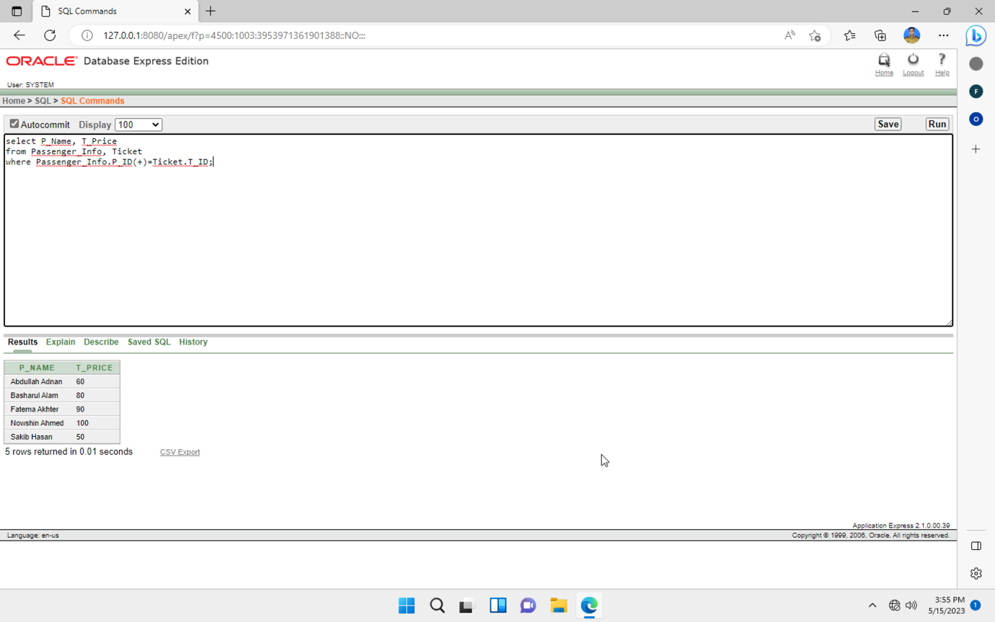

1. Perform a full outer join between the "Passenger_Info", "Station_Passenger", and "Station_Info" tables on the matching "P_ID" and "S_ID" columns. Retrieve the passenger name and station name for each matching record, including all records from all tables regardless of whether there is a match in the other tables.

SELECT P_Name, S_Name

FROM Passenger_Info, Station_Passenger, Station_Info

WHERE Passenger_Info.P_ID = Station_Passenger.P_ID

AND Station_Passenger.S_ID = Station_Info.S_ID;

**Joining(Self-join):**

1.Query that joins the "Passenger_Info" table with itself based on the "P_ID" column, retrieving the names of passengers and their fellow passengers who have the same boarding location.

SELECT p1.P_Name, p2.P_Name AS Fellow_Passenger

FROM Passenger_Info p1, Passenger_Info p2

WHERE p1.P_ID != p2.P_ID AND p1.Boarding = p2.Boarding;

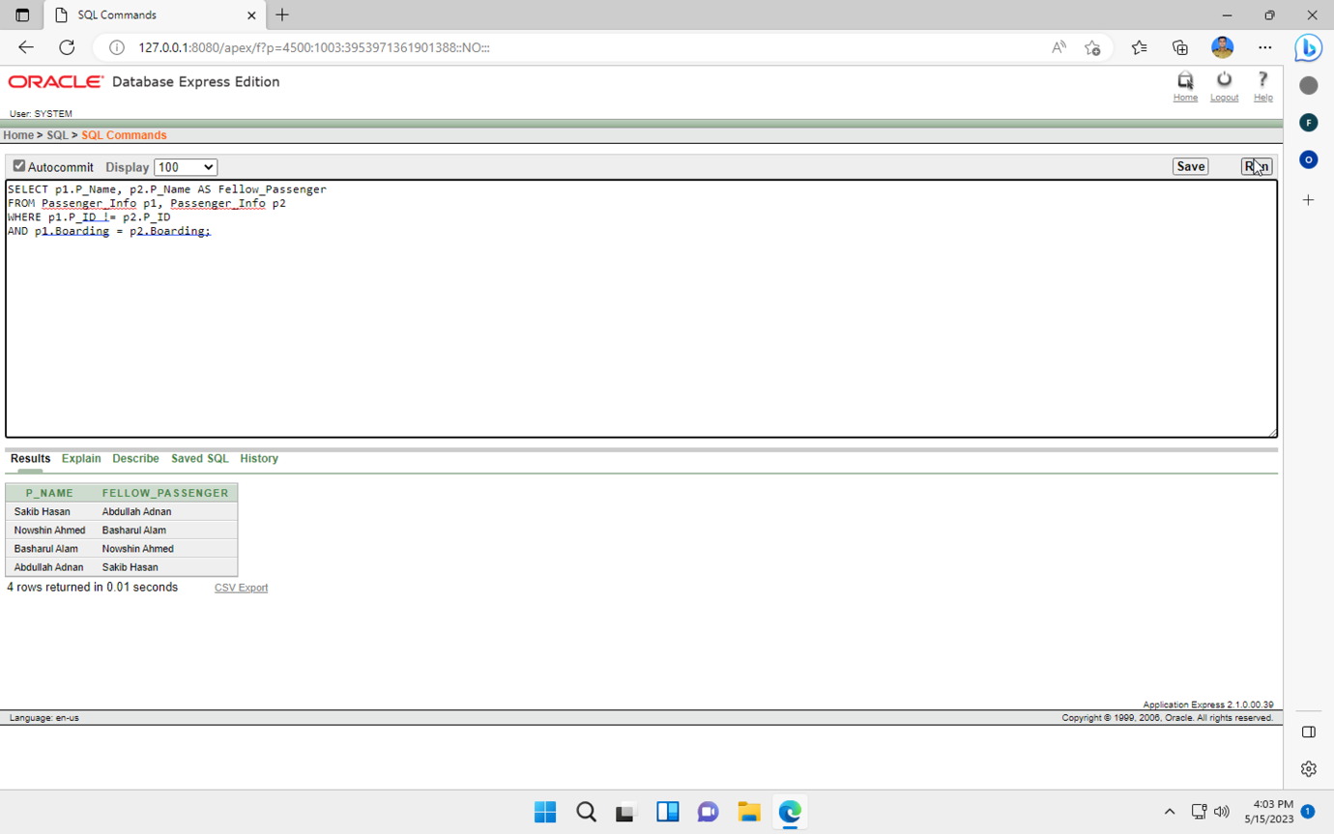

**Simple View:**

In this query, we create a view named "Metro_Stations" that retrieves the station ID and station name from the "Station_Info" table. The view allows us to access this information as if it were a virtual table.

CREATE VIEW Metro_Stations AS

SELECT S_ID, S_Name

FROM Station_Info;

SELECT *

FROM Metro_Stations;

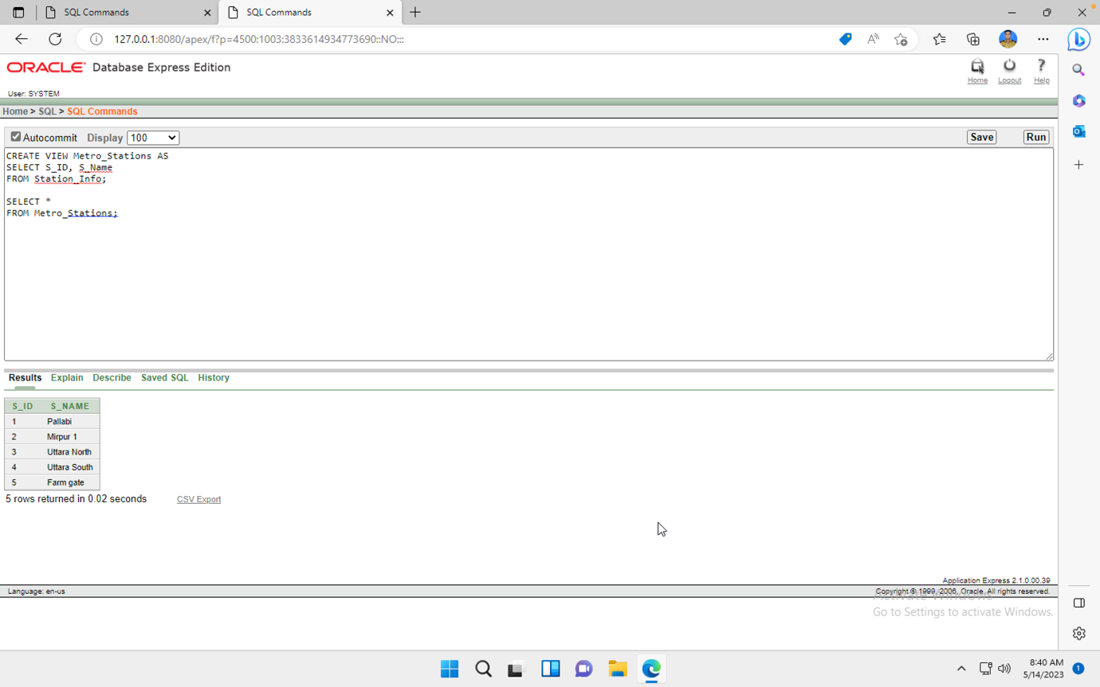

**Complex View:**

We create a view called "Passenger_Ticket_Info" that combines data from the "Passenger_Info" and "Ticket" tables. The view includes the passenger ID, name, destination, and ticket price for each matching record. It includes all records from the left table (Passenger_Info) even if there is no match in the right table (Ticket).

CREATE VIEW Passenger_Ticket_Info AS

SELECT p.P_ID, p.P_Name, p.Destination, t.T_Price

FROM Passenger_Info p

LEFT JOIN Ticket t ON p.P_ID = t.P_ID;

SELECT *

FROM Passenger_Ticket_Info;

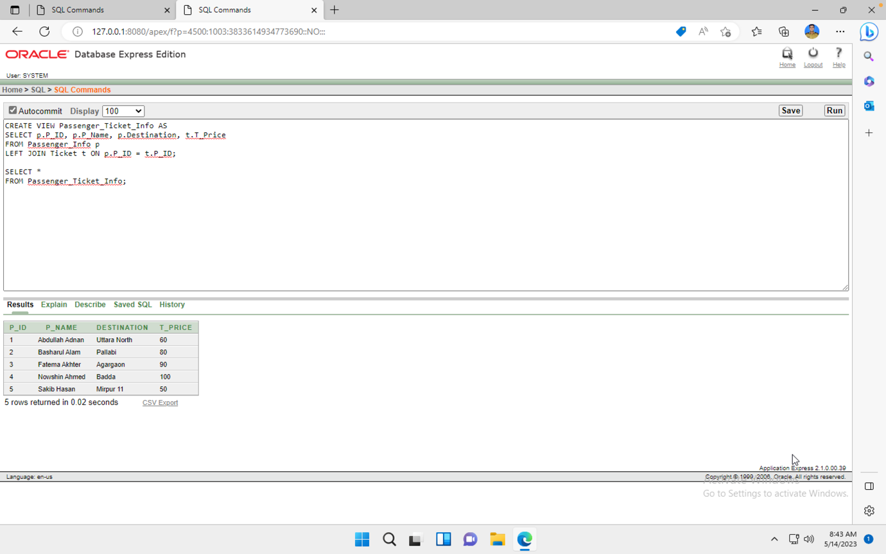

**Addition of Constraint:**

1.Query that adds a check constraint named "CHK_MT_Capacity" to the "Metro_Info" table, ensuring that the "MT_Capacity" column has values greater than 0.

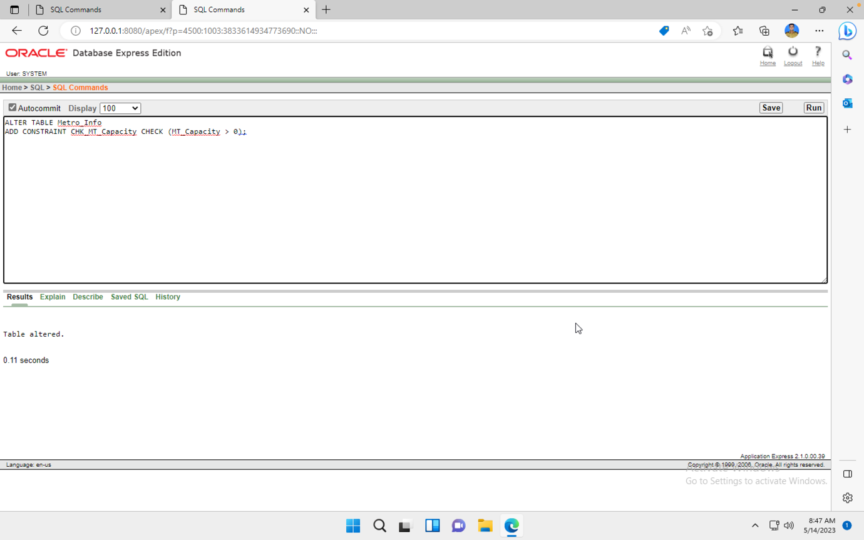

**Conclusion:**

In conclusion, a thorough and effective management system for metro rail operations has been created as part of the metro rail management database project. The database schema includes the essential linkages and constraints, as well as tables for metros, stations, travelers, staff, and ticketing. It makes it possible to manage, save, and retrieve information seamlessly while preserving the quality and integrity of the data. The initiative aids in efficient decision-making, analysis, and reporting, which helps the metro system run smoothly. The metro rail management database project, taken as a whole, offers a strong foundation for improving operational effectiveness, passenger management, employee administration, and ticketing activities in a metro rail setting.